St Andrews Parent Council (StAPC) – Minutes from meeting on 05/02/2018
Present:
GB - Gaby Barnaby (Chair), LB - Lou Brewer (Minutes), MT - Mark Taylor (Head Teacher), ID - Ingrid Drever (Teacher Representative), Fiona Holmes (Parent Representative), Gwen Simpson (Parent Representative), Aaron Cowieson (Parent Representative), AD - Andrew Drever (Councillor), Steve Sankey (Councillor)
GB welcomed everyone along to the meeting.
- Apologies
Apologies were given by Norman Craigie and Emma Thomson.

- Approval of minutes from previous meeting
Minutes of the meeting held on 14/11/17 were approved by those present to be an accurate account of the meeting.

- Matters Arising from minutes of previous meeting
Behaviour Management Policy – at the last Parents Chair Meeting a draft Policy has come through. MT looking at the policy and will give feedback and may update St. Andrews Behaviour Management Policy before the end of term. To be shared onto school FB page once agreed. ACTION: MT
- Approval of Parent Council Constitution
GB has amended to keep up with current terminology and changed date of handover of office bearer. GB will distribute amended constitution for approval. ACTION: GB

- Report from Chair of Parent Council
GB informed the meeting that the School calendars have been very popular. They made £200 and the 100 which are surplus can be used as a resource in the school. May be repeated as a fundraiser in 2 or 3 years time. Next time then plan would be to take photographs in the week before the October break, so that there would be more time to sell the calendars and they could be out for sale on Parent’s Evening.
The Christmas Show and raffle made £700 and Christmas Cards (organised by Mrs. Ewing) made around £500.
The Christmas show ‘Hey Ewe’ was hailed a great success and was commended by special guests from the Education Department.
The Facebook St Andrews Football page is working very well to keep parents and players informed.
School Disco – considered to be very lively and great fun for all. Council would like to thank DJ Alan Garriock. ACTION: MT

- Easter Show
Dates for the Easter show – last week of term – Tuesday 27th and Wednesday 28th March. The afternoon show would be on Tuesday at 2pm and the evening show would be on Wednesday at 7pm.

- Parents Evening
Will be held on the second last week of term - Tuesday 20th and Wednesday 21st of March from 1630 – 1930. More information to follow. No stall this year. ? Homework challenges for family participation, ideas to be discussed with teaching staff. ACTION: MT

- School Update from Head Teacher
Put out as a newsletter to the School Community.
St Andrews School Update: Parent Council 06.02.18
Christmas seems like a long time ago now, but while we still have dark nights and winter weather it is nice to look back at all the colourful events our children took part in before their holidays.
We began the season with the East Mainland Church Guild carol service at the beginning of December. Children and their families, staff and members of our community gathered to sing carols and to think about the Christmas story.
There was a Christmas disco at the school, organised by our Parent Council. Our community police officer, PC Garriock, surprised the children, arriving in her uniform to have a dance!
Our P7 children made us very proud when they provided musical entertainment at the St Andrews Senior Citizens lunch, then at St Rognvald’s House and the Lifestyles Centre.
‘Hey Ewe’, our Christmas Show, was a terrific success. All the hard work put in by the children and our staff was well worth it. We were pleased to invite our handwork helpers to attend the show; they come in to our school every week during the winter terms to help the children learn to sew, knit and crochet and we are very grateful for their support.
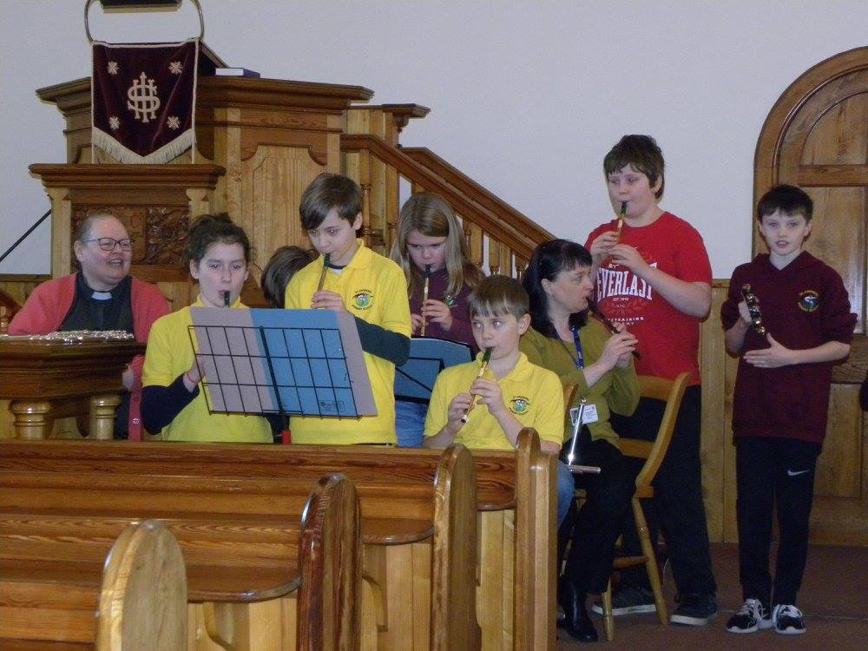
The children had another chance to sing some of the songs from the show at our Christmas Service in the Church. It was a very special celebration and it was great to share it with so many parents and friends.

At the service we took the opportunity to thank Helga Moss and Inga Gilmour, two of our long serving members of staff, who have left the school to take up new posts. We wish them well for the future.
We are now well in to the new year, and the weather has made it eventful so far! The bank at the back of the school is ideal for sledging and the children have made the most of it!

Lindsey Taylor, Education Officer with the RSPB, has been visiting our P2 class to help them to identify different birds, especially birds found here in Orkney. Lindsey helped the class take part in the ‘Big Schools Bird Watch’, a project where schools all over the UK record and learn about the birds found in their grounds.
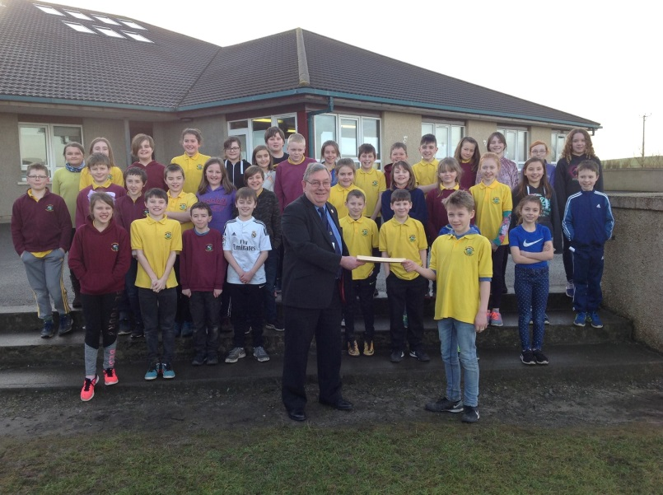
Our primary 6 pupils have been working extremely hard learning about different local and global issues in their topic 'Discovering Democracy'. They are most concerned about the use of plastics, especially single use plastics. They met with Councillor Graham Sinclair and Andrew Drever to hand over their letter detailing changes they would like to see happening; watch this space for developments!
Looking ahead, rehearsals have begun for our P6/7 show and we have World Book Day, Sports Relief and parents’ evenings all to come before the Easter holidays. There is much to look forward to!
DATES FOR YOUR DIARY – this list will be updated with further dates throughout the term.

World Book Day – Thursday 1st March

Parents’ Evenings
Parents’ evenings will be held on Tuesday 20th and Wednesday 21st March from 4.30 – 7.30pm. Letters will be issued nearer the time detailing how to book appointments.

Sports Relief

P6/7 Show – Ali Baba and the Bongo Bandits

February
Thursday 15th In-service day, school closed to pupils
Friday 16th School closed
Monday 19th School closed

March
Thursday 1st World Book Day
Tuesday 20th Parents’ Evening 4.30 – 7.30pm
Wednesday 21st Parents’ Evening 4.30 – 7.30pm
Friday 23rd Sports Relief
Tuesday 27th P6/7 show - dress rehearsal AM
Tuesday 27th P6/7 show 2.00pm
Wednesday 28th Easter Service 2.00pm
Wednesday 28th P6/7 show 7.00pm
Friday 30th Last day of term

April
Monday 16th First day of term

May
Monday 7th May Day holiday
Monday 21st P7 to Lagganlia
Friday 25th In-service day, school closed to pupils

July
Monday 2nd Last day of term

P3 will have football training beginning 21st February.
P4 & 5 will have swimming lessons beginning 20th April.

The Chess Club is now up and running (for the past three weeks). Ray and Pat are both commended in doing a fantastic job.

Handwork – MT did a survey of the pupils and 85% are keen to keep doing handwork.

- Self-Evaluation – ‘How Good is Our School?’
MT would like Parent council involvement in the School Improvement Plan. The document was discussed and it was agreed that the Parent Council would spend the first 20 minutes or so of the next meeting discussing and collaborating on ideas around either
Leadership or management, Learning Provision or Success and Achievements. Information will be sent out before the next meeting. SS noted that the new Educational Bill which was almost legislation will give increased power to Head Teachers. ACTION: MT

- AOB
St. Andrews Extension – nothing new to update. AD will enquire as to what is happening with this. ACTION: AD
Electric Vehicle Policy – MT enquired as to whether a charging point could be placed in the car park. AD will enquire. ACTION: AD

- Date of Next Meeting
The next meeting will be held at the school on the 13th March at 1830.

The Chair thanked everyone for attending and the meeting closed at 2030.

