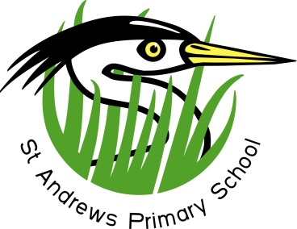
- Committed to excellent education for all -
March Bulletin 2017

March 2017

Dear Parents and Carers,

Capital Project
Our Capital Project, to allocate an additional £2.3 million to the already agreed £995k for our school extension, has today been agreed by the Orkney Islands Council Policy and Resources Committee. We are very grateful to our Councillors, especially those who voiced their support for our school at the meeting today, and to our Parent Council and members of our local community who wrote letters to the OIC in support of the project. Well done to our pupils who also wrote letters to our Councillors and made a video showing why they need more space.
We will keep you informed of the process and next steps going forward.
World Book Day
We will celebrate World Book Day here at the school on Thursday. Children are asked to bring in their favourite book to share with others in class. Staff members shall also be taking their favourite childhood book in to share. There will be a range of activities relating to reading happening throughout the day.
Musical Variety Show
The P4-7 Easter concert will be on Wednesday 22nd March. In a change to recent years, rather than a musical production, the children will perform a musical variety show with special guests from our local community; The Chair, Bill Robertson, Kenny Ritch (Senior), James Henry and St Andrews Singers (staff, parents and friends) will perform along with the children.
There will be two short concerts; one from 6 – 7pm and the next from 7.45 – 8.45pm. Tickets will be available from the school office from Monday, 6th March costing £3 and £5. We are looking forward to the new format! In future, we plan to have a large musical production bi-annually at Easter time.
Parents’ Evening
Parents’ evenings will be on Tuesday 28th and Wednesday 29th March. We will be displaying ‘Jigsaw’, a health and wellbeing resource that we have been trialling here at the school since October, and a member of staff will be available to answer any questions you may have about it. There will also be a Scholastic book fair where you will be able to purchase books and small items of stationery.

DATES FOR YOUR DIARY
Thursday 2nd March 2017 World Book Day
Wednesday 22nd March 2017 P4-7 Easter Variety Show
Friday 24th March 2017 Comic Relief
Tuesday 28th March 2017 Parents’ Evening
Wednesday 29th March 2017 Parents’ Evening
Friday 31st March 2017 Last day of term 3

Tuesday 18th April 2017 First day of term 4

Monday 1st May 2017 May Day holiday
Friday 19th May 2017 In-service day (school closed to pupils)

19-23rd June P7 Lagganlia Trip

Tuesday 4th July 2076 Last day of term 4

If you have any concerns or queries, please do not hesitate to contact me.

Kind Regards
Mark Taylor
Head Teacher

St Andrews Primary School
St Andrews, Orkney KW17 2QG
Tel: (01856) 861256 Fax: (01856) 861421
website: www.st-andrews.orkney.sch.uk
email: admin.standrews@glow.orkneyschools.org.uk

